1. Connect SpiRely to computer through TTL-USB tool.   
   Red to VCC, Black to GND, Green to Rx, and White to Tx.
2. Open YD14. Select and open COM port.  
   Download at <https://files.secureserver.net/0sSvU5kVOWASlH>

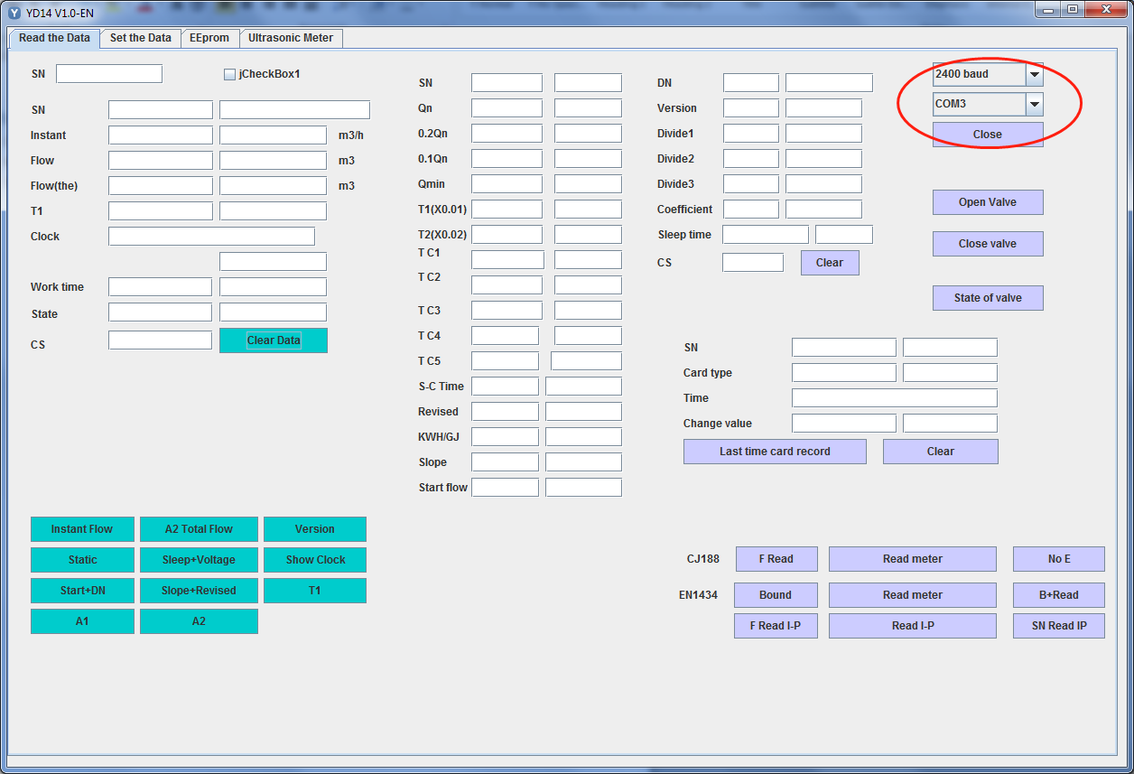

1. Click on the tab of Ultrasonic Meter and click on Calibrate Total to go to High Resolution mode.

